

# 1551 S. Vineyard Avenue

# Ontario, CA 91761

**(909) 923-1973**

## WIRING SCHEMATICS

FOR software versions GENERIC 541 and higher

### BASIC AUTOMOTIVE CONVERSION

**REVISION: C2**

**Date 4/2/2013**



THROTTLE CONFIGURATION

Depending of the type of throttle used for the application, see below table to determine the appropriate connection. Electrical schematics are also included in page 4 through 6.

|  |  |  |
| --- | --- | --- |
| **THROTTLE CONFIGURATION** | **TYPE** | **ELECTRICAL CONNECTIONS** |
| 2 WIRE with SWITCH 0-5k Ω | TYPE 2 | Connect PURPLE / WHITE wire labeled #18 with PURPLE / WHITE wire. Ending connection at throttle pot low.  YELLOW / WHITE wire connected to throttle wiper |
| 3 WIRE with SWITCH 0-5k Ω | TYPE 3 | Connect BLACK / WHITE wire labeled #15 with BLACK/ WHITE wire. Ending connection at throttle pot high.  Connect PURPLE / WHITE wire labeled #18 WITH PURPLE / WHITE wire. Ending connection at throttle pot low.  Connect YELLOW / WHITE wire connected to throttle wiper. |
| ELECTRONIC without SWITCH | TYPE 1 | Disconnect any wire connected to BLACK/WHITE wire labeled #15.  Disconnect any wire from PURPLE/ WHITE wire labeled #18.  Connect BLACK /BLUE WIRE LABELED #7 with BLACK/ BLUE wire. Ending connection at electronic throttle ground.  Connect RED/ WHITE wire labeled #26 with PURPLE / WHITE wire. Ending connection at throttle +5V input.   Connect YELLOW / WHITE wire to electronic throttle signal. |







PEDAL INTERLOCK CONNECTION

The pedal interlock connection is required for both 2 and 3 wire throttle pot assemblies. The Green wire is connected at Normally Closed tab. Red wire is connected at common tab. See below picture.

NOTE, when accelerator pedal IS PRESSED the interlock switch is released to its NORMAL position (switch not activated) thus completing the circuit since its green wire is connected to the normally closed (NC) connection.

Electronic throttles usually do not have an interlock switches. In this application, the Green and Red wires are connected together.

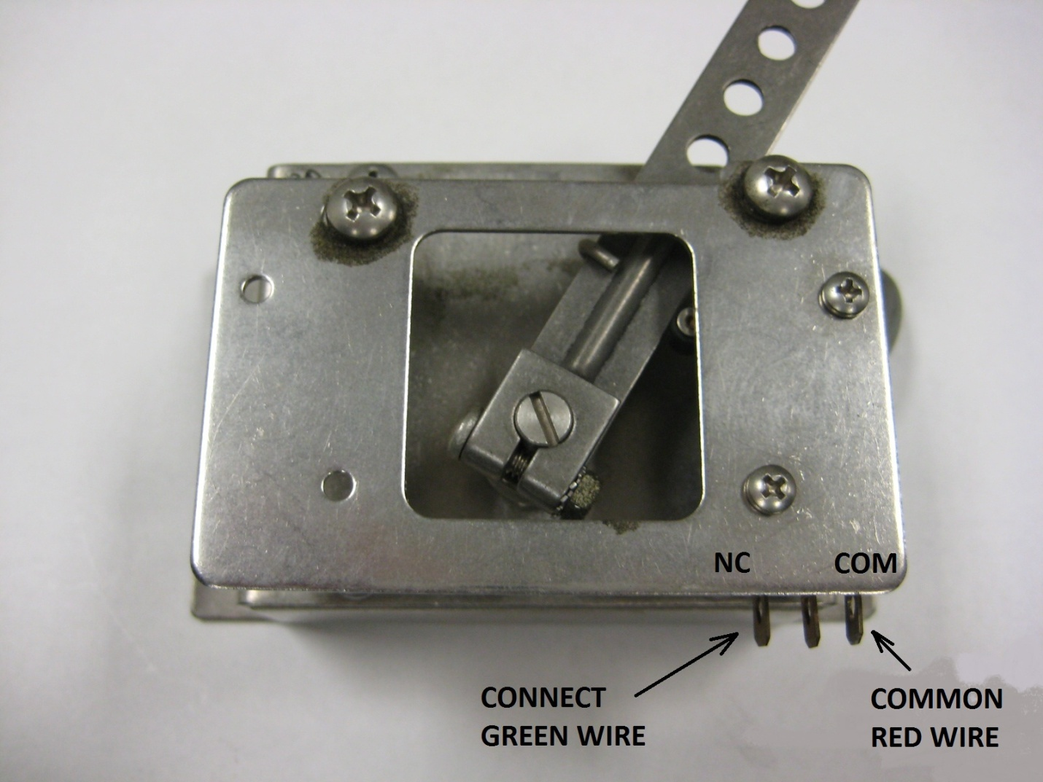

BRAKE POT CONFIGURATION

Depending of the type of brake pot used for the application, see below table to determine the appropriate connection. Electrical schematics are also included in page 9 & 10.

|  |  |  |
| --- | --- | --- |
| **BRAKE POT CONFIGURATION** | **TYPE** | **ELECTRICAL CONNECTIONS** |
| 2 WIRE with SWITCH 0-5k Ω | TYPE 2 | Connect PURPLE / WHITE wire labeled #18 with PURPLE / WHITE wire. Ending connection at brake pot low.  Connect YELLOW / RED wire labeled #17 with wire YELLOW/ RED wire. Ending connection at brake wiper. |
| BRAKE TRANSDUCER | TYPE 1 | Connect RED/ BLUE wire to brake transducer +12V input.  Connect BLACK/ BLUE wire labeled #7 with Black/BLUE wire. Ending connection at brake transducer ground.  Connect YELLOW / RED wire labeled #17 with wire YELLOW/ RED wire. Ending connection at brake transducer output signal. |





